Ideation phases
Brainstorm &Idea prioritization
Template
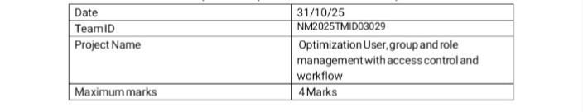

Optimization user, group and role management with access control and workflows template:

To optimize user, group, and role management with access control and workflows, define roles based on the principle of least privilege, assign permissions to groups, and use role-based access control (RBAC) to streamline administration. Implement automated workflows for access requests and approvals to reduce manual tasks, and set up clear rules for access, preferring “allow” over “deny” policies to simplify maintenance and security auditing.

Key optimization strategies include defining clear roles, using groups to manage users efficiently, establishing specific access levels (like view-only or read/write), and implementing workflows that require role-based approval. Centralizing role management and regularly auditing user activities are also crucial for maintaining security and efficiency.
Step-1: Team Gathering, collaboration and select the
problem statement:
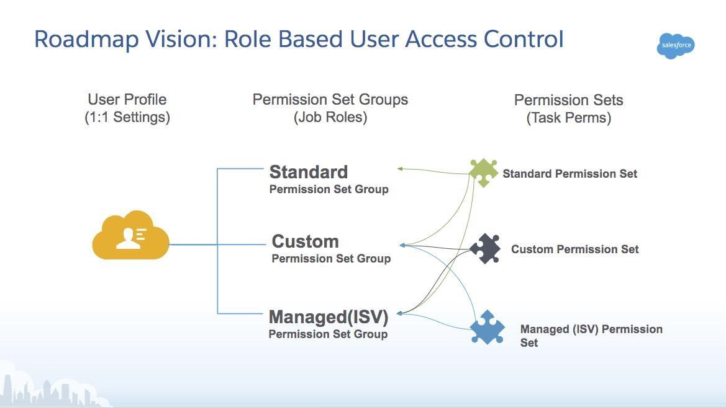
Step-2: Brainstorm , idea, Listing and Grouping:
Idea Listing:
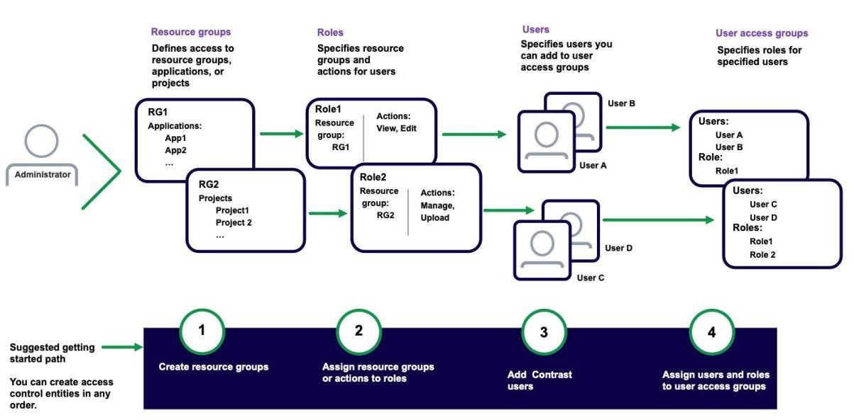

Fig2: Image that describes the work done by teammates:
Brainstorm:
Team member shared the ideas freely to explore solution without judgement, encouraging creativity and participation.
Idea Listing:
All ideas from session are written down to capture every suggestion and ensure no input is overlooked.
Grouping:
Similar ideas are organised into categories to identify the patterns, highlight, priorities and simplify the decision making.
Action plans
Choose an ideas are turned into clear steps with assigned responsibilities and timelines

Step -3: Idea prioritization:

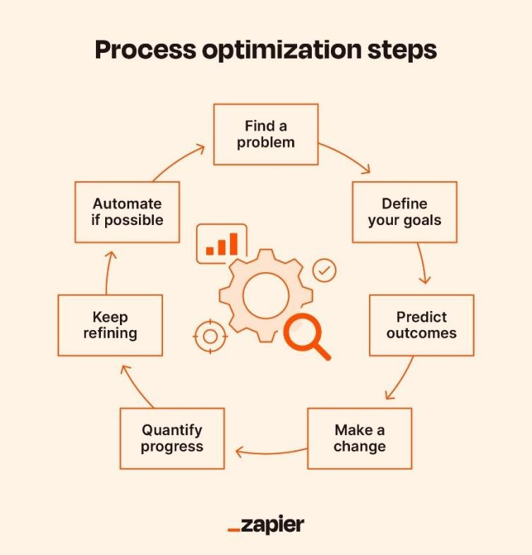

Fig 3: image of steps to prevent user deletion:

Idea prioritization:

Idea prioritization help break down complex projects into clear, focused components in this project main goal is to prevent user deletions . If the account is assigned to an active incident. This approach ensures that a data integrity under accountability are maintained during critical workflow. By polarizing ideas, we can separate incident management processes from routine administrative tasks. It is helps in highlighting the important user account security and controlled access. Each steps from detection to restriction, becomes easier to plan and implement. Clear visual representation like diagrams and a flowchart can simplify communication . Overall the idea polarization strengthens project clarity and support smooth execution

